Part 1 working with functions

- Write a python program using a function to print factorial number series from n to m numbers.
def facto():
n=int(input("Enter the number:"))
f=1
for i in range(1,n+1):
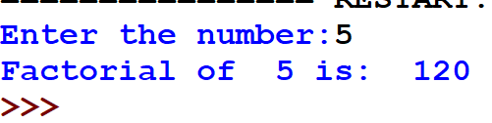
f*=i
print("Factorial of ",n, "is: ",f, end=" ")
facto()

- Write a python program to accept username "Admin" as default argument and password 123 entered by user to allow login into the system.
def user_pass(password,username="Admin"):
if password=='123':
print("You have logged into system")
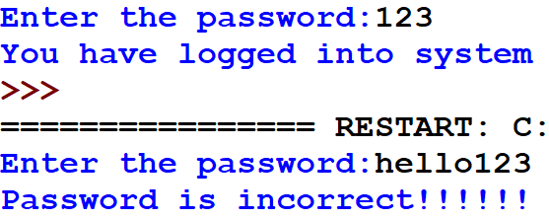
else:
print("Password is incorrect!!!!!!")
password=input("Enter the password:")
user_pass(password)

- Write a python program to demonstrate the concept of variable length argument to calculate product and power of the first 10 numbers.
def sum10(*n):
total=0
for i in n:
total=total + i
print("Sum of first 10 Numbers:",total)
sum10(1,2,3,4,5,6,7,8,9,10)
def product10(*n):
pr=1
for i in n:
pr=pr * i
print("Product of first 10 Numbers:",pr)
product10(1,2,3,4,5,6,7,8,9,10)

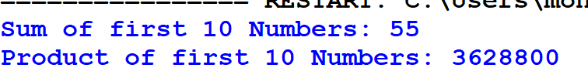

Part 3 exception handling
- Write a Python program to accept a list as a function parameter and raise the IndexError exception.
Solution:
#Program to print appropriate weeks from entered numbers and display error message through exception handling
def raise_index_error(lst):
try:
idx=int(input("Enter list index to access the value"))
print(lst[idx])
except IndexError:
print("Index not found in the list")
def main():
l=eval(input("Enter the list:"))
raise_index_error(l)
main()
Output:
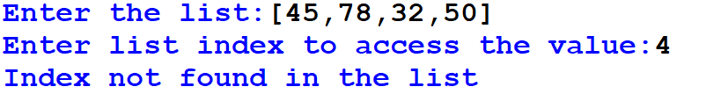

- Write a program to accept the number of days and display appropriate weeks in an integer. Display an appropriate error message through multiple exception handling including the finally clause.
Solution:
#Program to print appropriate weeks from entered numbers and display error message through exception handling
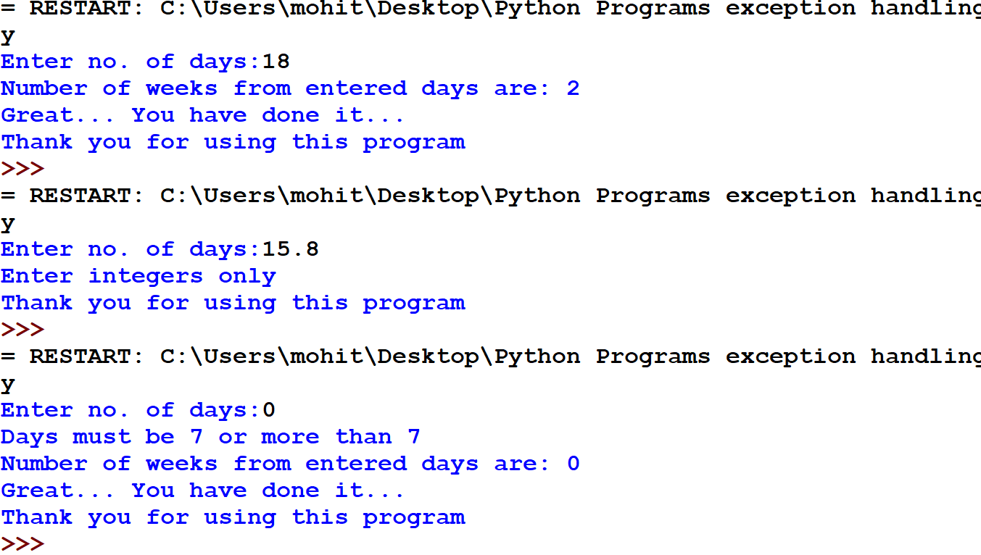
def weeks_compute(days):
if days>=7:
return int(days/7)
else:
print("Days must be 7 or more than 7")
return 0
def except_weeks():
try:
days=int(input("Enter no. of days:"))
weeks=weeks_compute(days)
print("Number of weeks from entered days are:",weeks)
except ValueError:
print("Enter integers only")
except ZeroDivisionError:
print("Number days should not be zero")
else:
print("Great... You have done it...")
finally:
print("Thank you for using this program")

Part 2 Data file handling

- Create a text file "intro.txt" in python and ask the user to write a single line text by user input.
def program4():
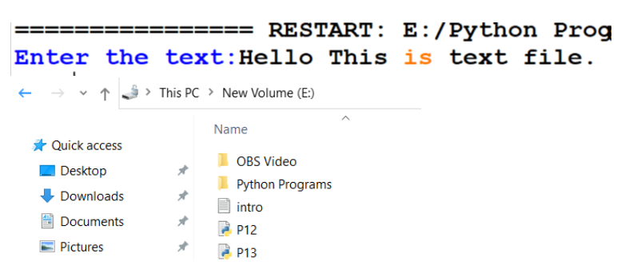
f = open("intro.txt","w")
text=input("Enter the text:")
f.write(text)
f.close(
program4()

- Write a program to count a total number of lines and count the total number of lines starting with 'A', 'B', and 'C' from the file myfile.txt.
def program5():
with open("MyFile.txt","r") as f1:
data=f1.readlines()
File Contents:
Python is super and trending language.
Allows to store the output in the files.
A text file stores textual data.
Binary files can handle binary data.
Binary files use pickle module to store data.
CSV files can handle tabular data.
CSV files can be read easily using CSV reader object.
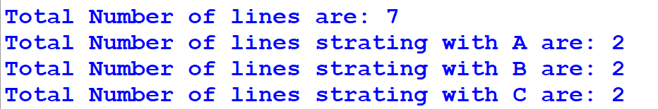
cnt_lines=0
cnt_A=0
cnt_B=0
cnt_C=0
for lines in data:
cnt_lines+=1
if lines[0]=='A':
cnt_A+=1
if lines[0]=='B':
cnt_B+=1
if lines[0]=='C':
cnt_C+=1
print("Total Number of lines are:",cnt_lines)
print("Total Number of lines strating with A are:",cnt_A)
print("Total Number of lines strating with B are:",cnt_B)
print("Total Number of lines strating with C are:",cnt_C)
program5()

- Write a program to replace all spaces from text with - (dash) from the file intro.txt.
def program6():
cnt = 0
with open("intro.txt","r") as f1:
data = f1.read()
data=data.replace(' ','-')
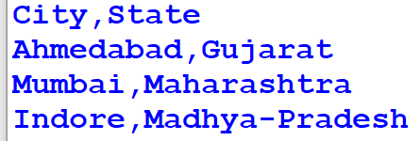
with open("intro.txt","w") as f1:
f1.write(data)
with open("intro.txt","r") as f1:
print(f1.read())
program6()
- Write a program to know the cursor position and print the text according to the below-given specifications:

  - Print the initial position
  - Move the cursor to 4th position
  - Display next 5 characters
  - Move cursor to next 10 characters
  - Print the current cursor position
  - Print next 10 characters from current position

def program7():
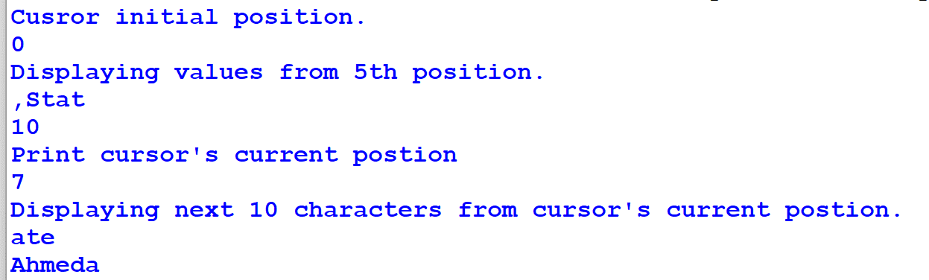
f = open("intro.txt","r")
print("Cusror initial position.")
print(f.tell())
f.seek(4,0)
print("Displaying values from 5th position.")
print(f.read(5))
f.seek(10,0)
print(f.tell())
print("Print cursor's current postion")
print(f.seek(7,0))
print("Displaying next 10 characters from cursor's current postion.")
print(f.read(10))
program7()

- Create a binary file client.dat to hold records like ClientID, Client name, and Address using the dictionary. Write functions to write data, read them, and print on the screen.
import pickle
rec={}
def file_create():
f=open("client.dat","wb")
cno = int(input("Enter Client ID:"))
cname = input("Enter Client Name:")
address = input("Enter Address:")
rec={cno:[cname,address]}
pickle.dump(rec,f)
def read_data():
f = open("client.dat","rb")
print("*"*78)
print("Data stored in File....")
rec=pickle.load(f)
for i in rec:
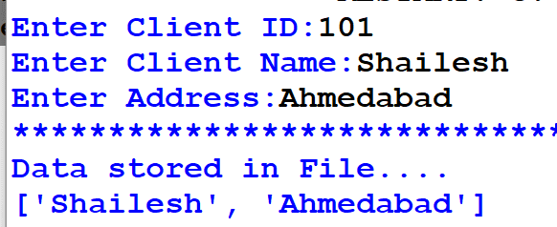
print(rec[i])
file_create()
read_data()
- Write a program to update a record from student.dat file by its rollno. Display the updated record on screen.
import pickle as p
rec=[]
found=0
f=open("student.dat","rb+")
r=p.load(f)
print("Existing Record:",r)
ro=int(input("Enter roll no to update:"))
for i in r:
if ro==i[0]:
i[1]=input("Enter new name:")
found=1
break
if found==0:
print("record not found..")
else:
f.seek(0)
p.dump(r,f)
print('Record Updated...')
f.close()

f1=open('student.dat','rb+')
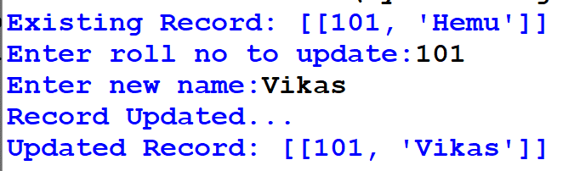
r=p.load(f1)
print("Updated Record:",r)
f1.close()

- Write a program to write data into binary file marks.dat and display the records of students who scored more than 95 marks.
import pickle
def search_95plus():
f = open("marks.dat","ab")
while True:
rn=int(input("Enter the rollno:"))
sname=input("Enter the name:")
marks=int(input("Enter the marks:"))
rec=[]
data=[rn,sname,marks]
rec.append(data)
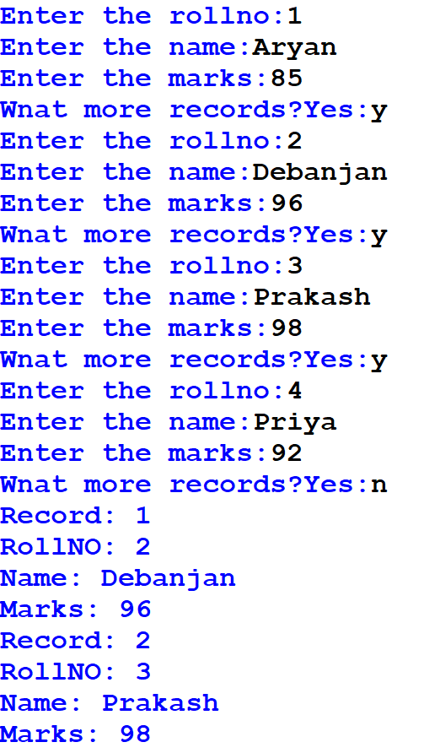
pickle.dump(rec,f)
ch=input("Wnat more records?Yes:")
if ch.lower() not in 'yes':
break
f.close()
f = open("marks.dat","rb")
cnt=0
try:
while True:
data = pickle.load(f)
for s in data:
if s[2]>95:
cnt+=1
print("Record:",cnt)
print("RollNO:",s[0])
print("Name:",s[1])
print("Marks:",s[2])
except Exception:
f.close()
search_95plus()
- Read a CSV file top5.csv and print the contents in a proper format. The data for top5.csv file are as following:
SNo | Batsman | Team | Runs | Highest
1 | K L Rahul | KXI | 670 | 132*
2 | S Dhawan | DC | 618 | 106*
3 | David Warner | SRH | 548 | 85*
4 | Shreyas Iyer | DC | 519 | 88*
5 | Ishan Kishan | MI | 516 | 99
from csv import reader
def pro1():
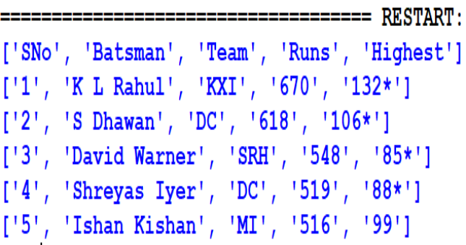
with open("top5.csv","r") as f:
d = reader(f)
data=list(d)
for i in data:
print(i)
pro1()
- Read a CSV file top5.csv and print them with tab delimiter. Ignore first row header to print in tabular form.
from csv import reader
def pro12():
f = open("e:\\top5.csv","r")
dt = reader(f,delimiter=',')
headr_row=next(dt)
data = list(dt)
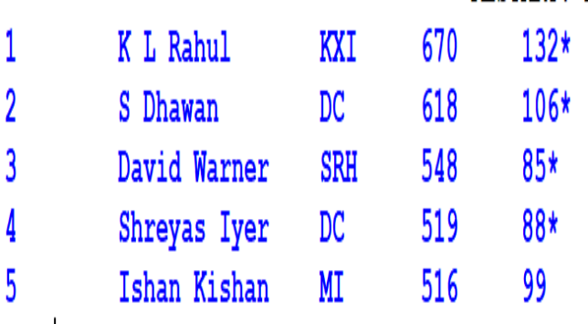
f.close()
for i in data:
for j in i:
print(j,"\t",end=" ")
print()
pro12()

- Read a CSV file students.csv and print them with tab delimiter. Ignore first row header to print in tabular form.
Field 1 | Data Type
StudentID | Integer
StudentName | String
Score | Integer

from csv import writer
def pro13():
#Create Header First
f = open("result.csv","w",newline='\n')
dt = writer(f)
dt.writerow(['Student_ID','StudentName','Score'])
f.close()
#Insert Data
f = open("result.csv","a",newline='\n')
while True:
st_id= int(input("Enter Student ID:"))
st_name = input("Enter Student name:")
st_score = input("Enter score:")
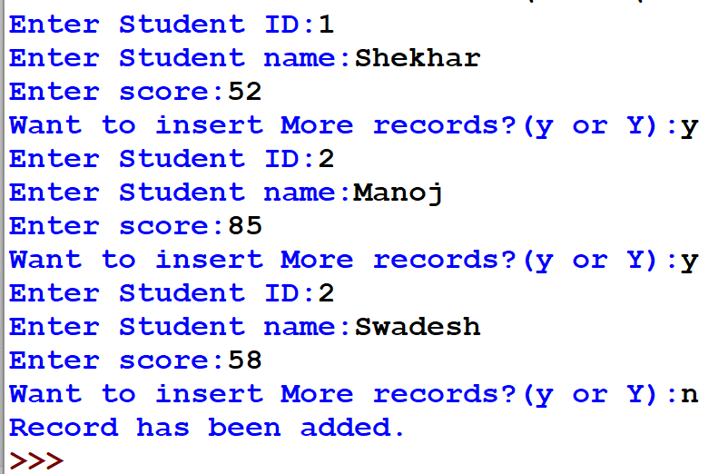
dt = writer(f)
dt.writerow([st_id,st_name,st_score])
ch=input("Want to insert More records?(y or Y):")
ch=ch.lower()
if ch !='y':
break
print("Record has been added.")
f.close()
pro13()
Part 3 Data Structure
- Write a menu-driven python program to implement stack operation.
def check_stack_isEmpty(stk):
if stk==[]:
return True
else:
return False
# An empty list to store stack elements, initially empty
s=[]
top = None # This is top pointer for push and pop

def main_menu():
while True:
print("Stack Implementation")
print("1 - Push")
print("2 - Pop")
print("3 - Peek")
print("4 - Display")
print("5 - Exit")
ch = int(input("Enter the your choice:"))
if ch==1:
el = int(input("Enter the value to push an element:"))
push(s,el)
elif ch==2:
e=pop_stack(s)
if e=="UnderFlow":
print("Stack is underflow!")
else:
print("Element popped:",e)
elif ch==3:
e=pop_stack(s)
if e=="UnderFlow":
print("Stack is underflow!")
else:
print("The element on top is:",e)
elif ch==4:
display(s)
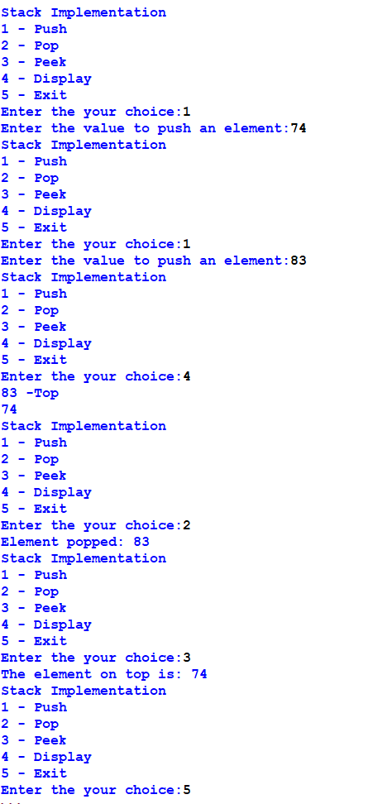
elif ch==5:
break
else:
print("Sorry,invalid option")

def push(stk,e):
stk.append(e)
top = len(stk)-1

def display(stk):
if check_stack_isEmpty(stk):
print("Stack is Empty")
else:
top = len(stk)-1
print(stk[top],"-Top")
for i in range(top-1,-1,-1):
print(stk[i])

def pop_stack(stk):
if check_stack_isEmpty(stk):
return "UnderFlow"
else:
e = stk.pop()
if len(stk)==0:
top = None
else:
top = len(stk)-1
return e
def peek(stk):
if check_stack_isEmpty(stk):
return "UnderFlow"
else:
top = len(stk)-1
return stk[top]

- Write a program to implement a stack for the employee details (empno, name).
stk=[]
top=-1
def line():
print('~'*100)

def isEmpty():
global stk
if stk==[]:
print("Stack is empty!!!")
else:
None
def push():
global stk
global top
empno=int(input("Enter the employee number to push:"))
ename=input("Enter the employee name to push:")
stk.append([empno,ename])
top=len(stk)-1
def display():
global stk
global top
if top==-1:
isEmpty()
else:
top=len(stk)-1
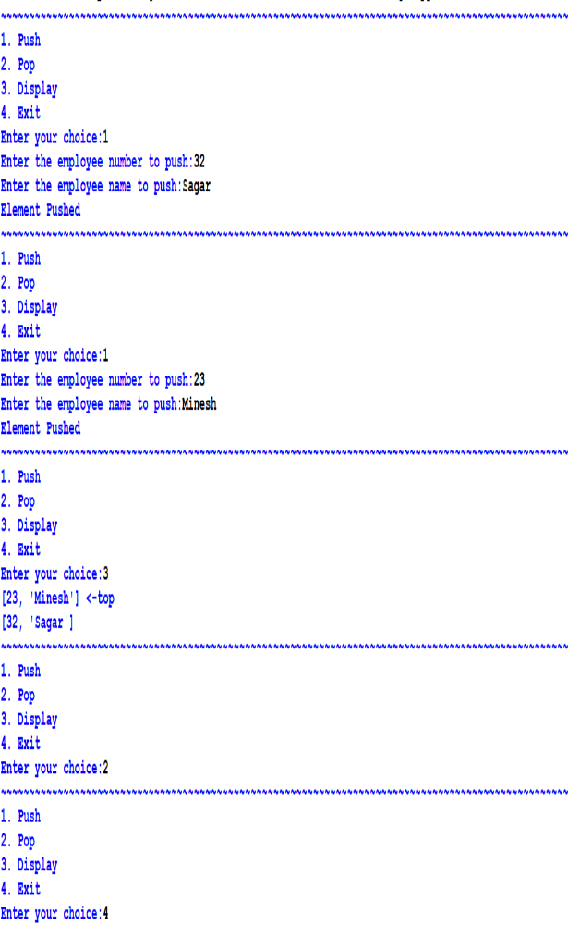
print(stk[top],"<-top")
for i in range(top-1,-1,-1):
print(stk[i])
def pop_ele():
global stk
global top
if top==-1:
isEmpty()
else:
stk.pop()
top=top-1
def main():
while True:
line()
print("1. Push")
print("2. Pop")
print("3. Display")
print("4. Exit")
ch=int(input("Enter your choice:"))
if ch==1:nm
push()
print("Element Pushed")
elif ch==2:
pop_ele()
elif ch==3:
display()
elif ch==4:
break
else:
print("Invalid Choice")
- Write a python program to check whether a string is a palindrome or not using stack.
stack = []
top = -1
# push function
def push(ele):
global top
top += 1
stack[top] = ele
# pop function
def pop():
global top
ele = stack[top]
top -= 1
return ele
# Function that returns 1 if string is a palindrome
def isPalindrome(string):
global stack
length = len(string)
# Allocating the memory for the stack
stack = ['0'] * (length + 1)
# Finding the mid
mid = length // 2
i = 0
while i < mid:
push(string[i])
i += 1
# Checking if the length of the string is odd then neglect the middle character
if length % 2 != 0:
i += 1
# While not the end of the string
while i < length:
ele = pop()
# If the characters differ then the given string is not a palindrome
if ele != string[i]:
return False
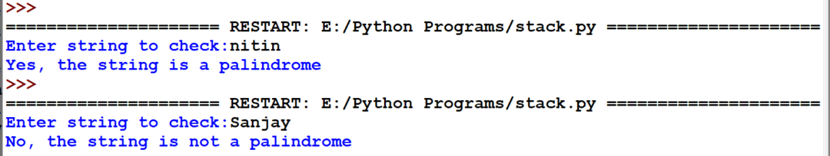
i += 1
return True
string = input("Enter string to check:")
if isPalindrome(string):
print("Yes, the string is a palindrome")
else:
print("No, the string is not a palindrome")

Part 4 sql queries

- Consider the following MOVIE table and write the SQL queries based on it.
Movie_ID | MovieName | Type | ReleaseDate | ProductionCost | BusinessCost
M001 | Dahek | Action | 2022/01/26 | 1245000 | 1300000
M002 | Attack | Action | 2022/01/28 | 1120000 | 1250000
M003 | Looop Lapeta | Thriller | 2022/02/01 | 250000 | 300000
M004 | Badhai Do | Drama | 2022/02/04 | 720000 | 68000
M005 | Shabaash Mithu | Biography | 2022/02/04 | 1000000 | 800000
M006 | Gehraiyaan | Romance | 2022/02/11 | 150000 | 120000
- Display all information from movie.
- Display the type of movies.
- Display movieid, moviename, total_eraning by showing the business done by the movies. Claculate the business done by movie using the sum of productioncost and businesscost.
- Display movieid, moviename and productioncost for all movies with productioncost greater thatn 150000 and less than 1000000.
- Display the movie of type action and romance.
- Display the list of movies which are going to release in February, 2022.
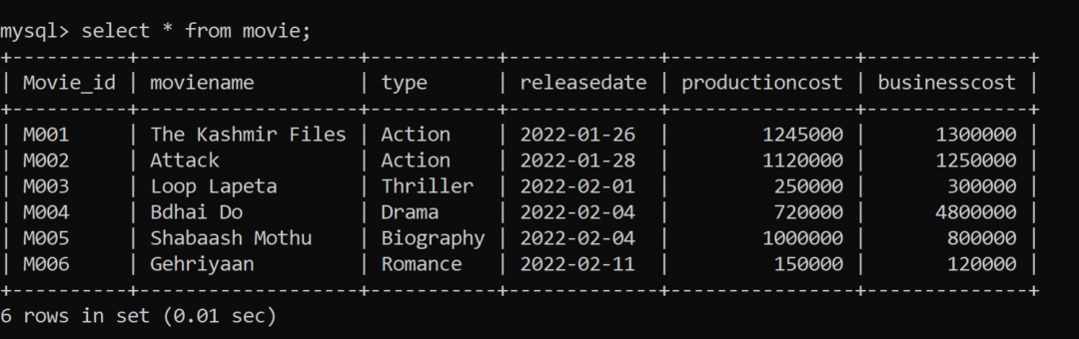
Answers:
- select * from movie;
- select distinct from a movie;
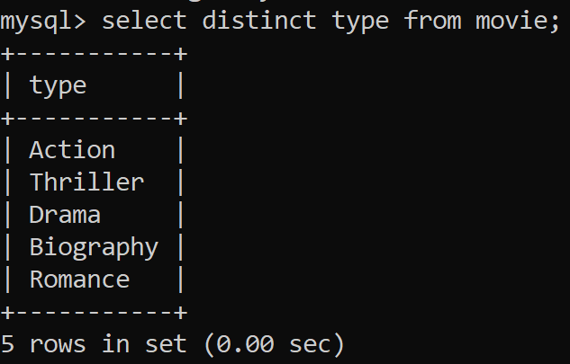
- select movieid, moviename, productioncost + businesscost "total earning" from movie;
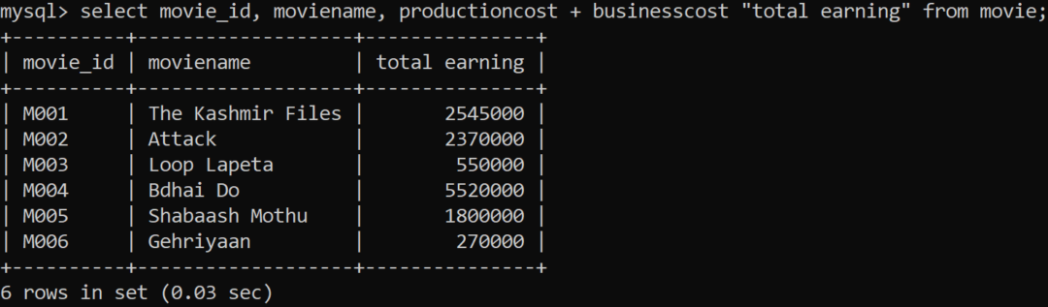
- select movie_id,moviename, productioncost from movie where producst is >150000 and <1000000;
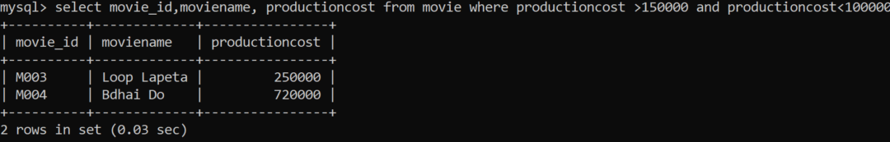
- select moviename from movie where type ='action' or type='romance';
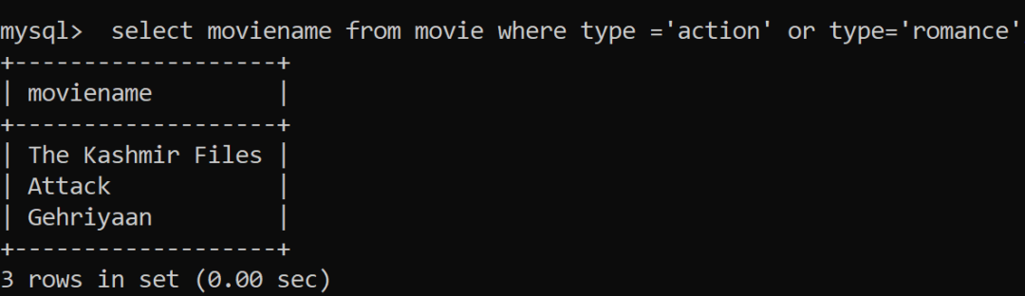

- select moviename from movie where month(releasedate)=2;
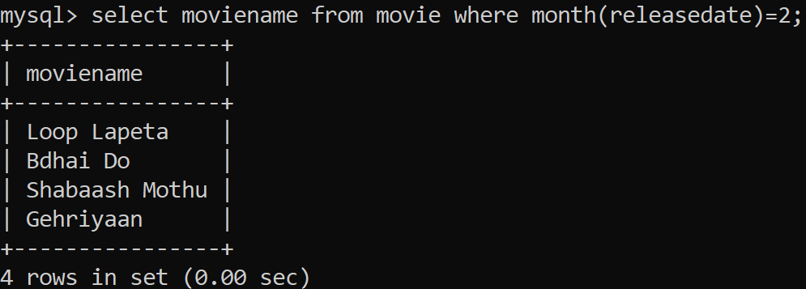

- Consider the given table patient and Write following queries:
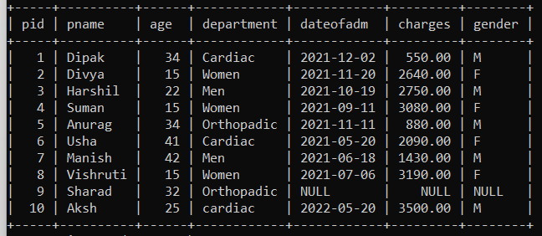
- Display the total charges of patient admitted in the month of November.
- Display the eldest patient with name and age.
- Count the unique departments.
- Display an average charges.
Answers:
- select sum(charges) from patient
where dateofadm like '%-11-%';
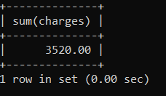

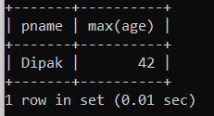
- select pname,max(age) from patient;

- Select count(distinct department) from patient;
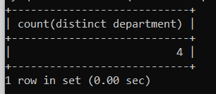

- Select avg(charges) from patient;
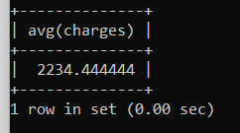

- Suppose your school management has decided to conduct cricket matches between students of Class XI and Class XII. Students of each class are asked to join any one of the four teams – Team Titan, Team Rockers, Team Magnet and Team Hurricane. During summer vacations, various matches will be conducted between these teams. Help your sports teacher to do the following:
- Create a database “Sports”.
- Create a table “TEAM” with following considerations:
  - It should have a column TeamID for storing an integer value between 1 to 9, which refers to unique identification of a team.
  - Each TeamID should have its associated name (TeamName), which should be a string of length not less than 10 characters.
  - Using table level constraint, make TeamID as the primary key.
- Show the structure of the table TEAM using a SQL statement.
- As per the preferences of the students four teams were formed as given below. Insert these four rows in TEAM table:

  - Row 1: (1, Tehlka)
  - Row 2: (2, Toofan)
  - Row 3: (3, Aandhi)
  - Row 3: (4, Shailab)

- Show the contents of the table TEAM using a DML statement.
- Now create another table MATCH_DETAILS and insert data as shown below. Choose appropriate data types and constraints for each attribute.
MatchID | MatchDate | FirstTeamID | SecondTeamID | FirstTeamScore | SecondTeamScore
M1 | 2021/12/20 | 1 | 2 | 107 | 93
M2 | 2021/12/21 | 3 | 4 | 156 | 158
M3 | 2021/12/22 | 1 | 3 | 86 | 81
M4 | 2021/12/23 | 2 | 4 | 65 | 67
M5 | 2021/12/24 | 1 | 4 | 52 | 88
M6 | 2021/12/25 | 2 | 3 | 97 | 68
Answers:
- create database sports;
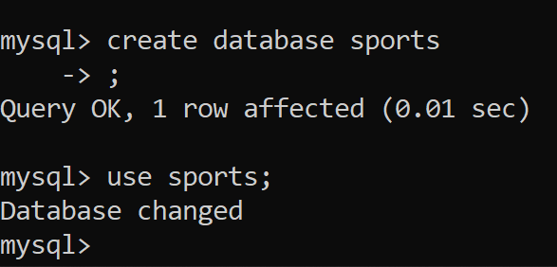
- Creating table with the given specification
create table team
(teamid int(1),
teamname varchar(10), primary key(teamid));

- desc team;
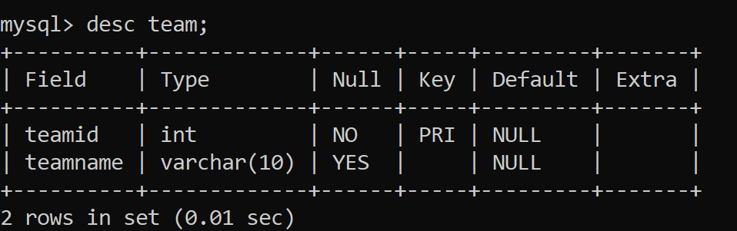
- Inserting data:
mqsql> insert into team values(1,'Tehlka');
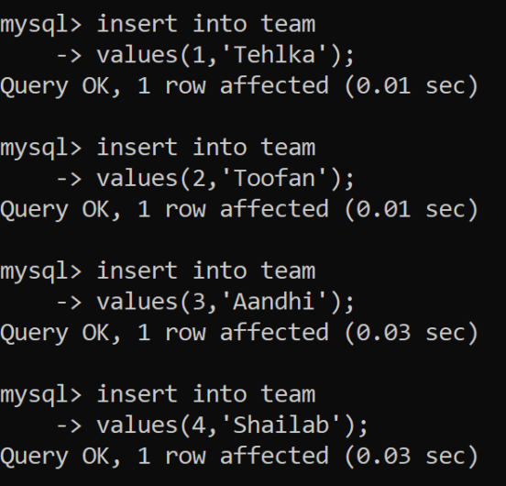
- Show the content of table - team:
select * from team;
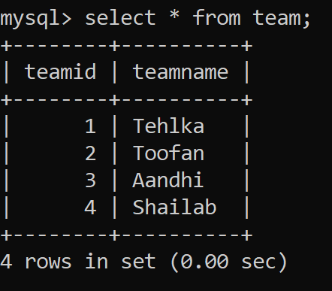
- Creating another table:
create table match_details
-> (matchid varchar(2) primary key,
-> matchdate date,
-> firstteamid int(1) references team(teamid),
-> secondteamid int(1) references team(teamid),
-> firstteamscore int(3),
-> secondteamscore int(3));
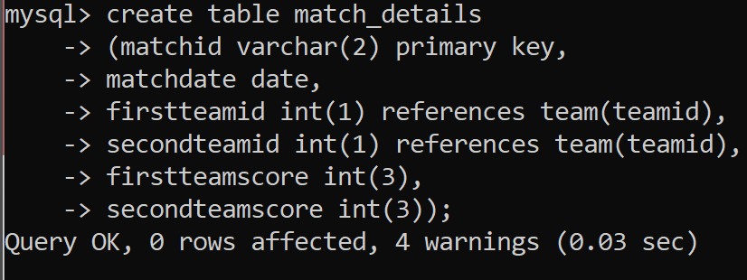
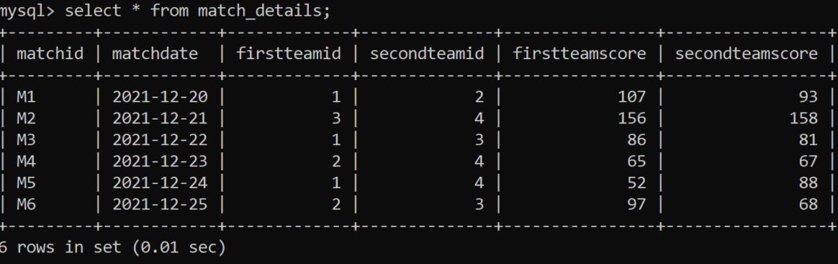
- Write following queries:
- Display the matchid, teamid, teamscore whoscored more than 70 in first ining along with team name.
- Display matchid, teamname and secondteamscore between 100 to 160.
- Display matchid, teamnames along with matchdates.
- Display unique team names
- Display matchid and matchdate played by Anadhi and Shailab.
Answers:
- select match_details.matchid, match_details.firstteamid, team.teamname,match_details.firstteamscore from match_details, team where match_details.firstteamid = team.teamid and match_details.first
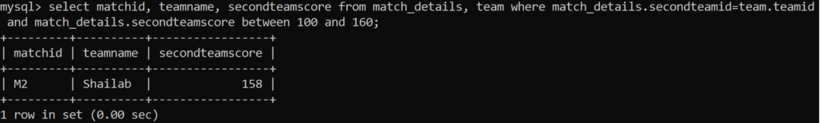
- select match_details.matchid, match_details.firstteamid, team.teamname,match_details.firstteamscore from match_details, team where match_details.firstteamid = team.teamid and match_details.firstteamscore>70;

- select matchid, teamname, firstteamid, secondteamid, matchdate from match_details, team where match_details.firstteamid = team.teamid;
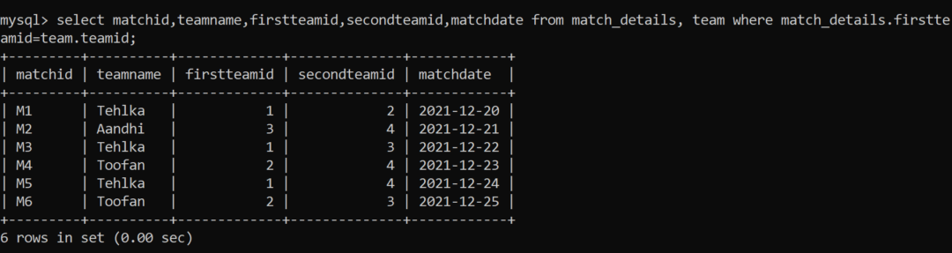
- select distinct(teamname) from match_details, team where match_details.firstteamid = team.teamid;
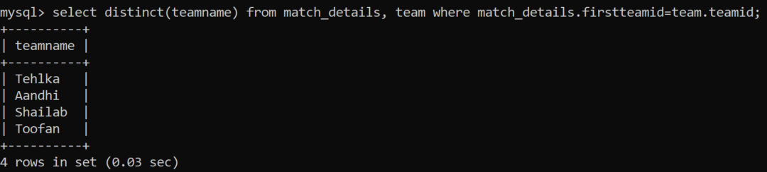
- select matchid,matchdate from match_details, team where match_details.firstteamid = team.teamid and team.teamname in ('Aandhi','Shailab');
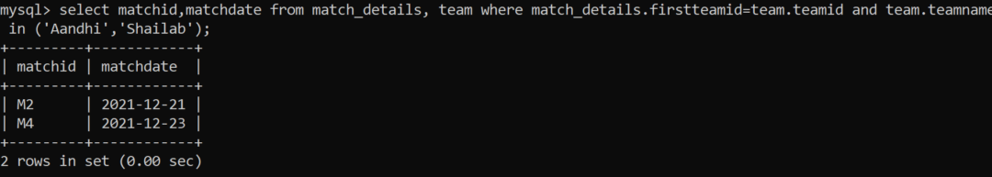
- Consider the following table and write the queries:
itemno | Item | dcode | qty | unitprice | stockdate
S005 | Ballpen | 102 | 100 | 10 | 2018/04/22
S003 | Gel Pen | 101 | 150 | 15 | 2018/03/18
S002 | Pencil | 102 | 125 | 5 | 2018/02/25
S006 | Eraser | 101 | 200 | 3 | 2018/01/12
S001 | Sharpner | 103 | 210 | 5 | 2018/06/11
S004 | Compass | 102 | 60 | 35 | 2018/05/10
S009 | A4 Papers | 102 | 160 | 5 | 2018/07/17
- Display all the items in the ascending order of stockdate.
- Display maximum price of items for each dealer individually as per dcode from stock.
- Display all the items in descending orders of itemnames.
- Display average price of items for each dealer individually as per doce from stock which avergae price is more than 5.
- Diisplay the sum of quantity for each dcode.
Answers:
a) select * from stock order by stockdate;
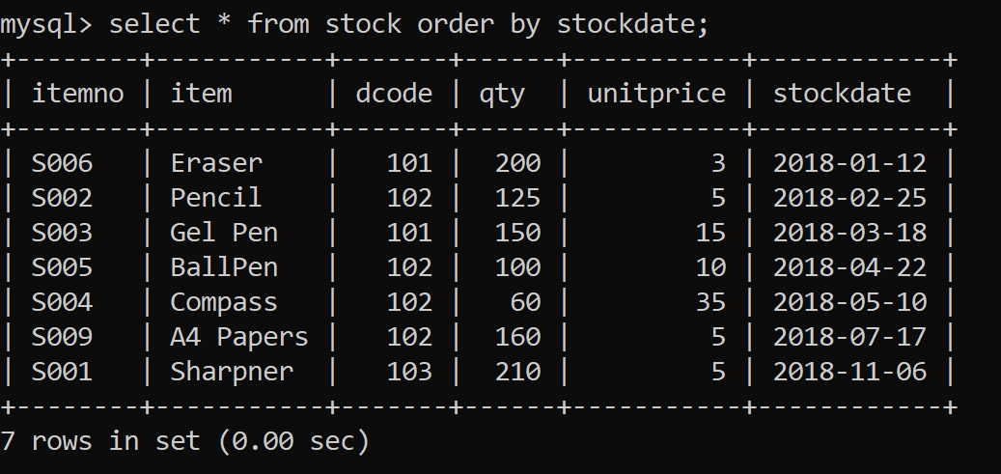
b) select dcode,max(unitprice) from stock group by code;
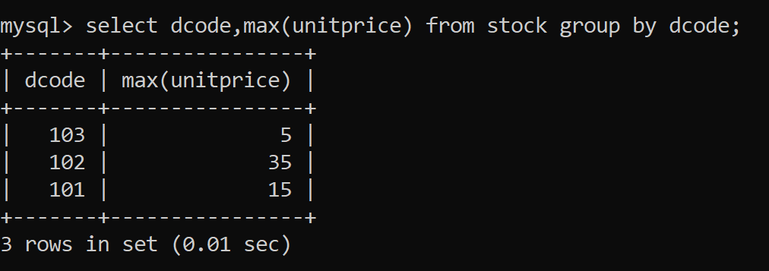
c) select * from stock order by item desc;
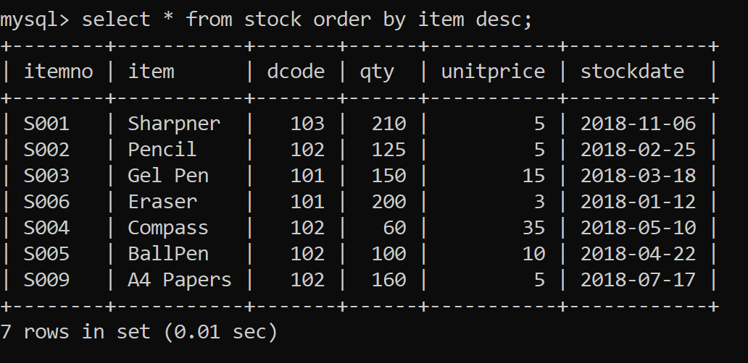
- select dcode,avg(unitprice) from stock group by dcode having avg(unitprice)>5;
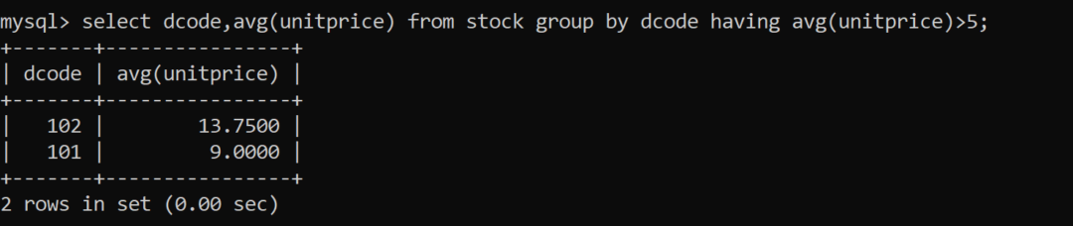
- select dcode,sum(qty) from stock group by dcode;
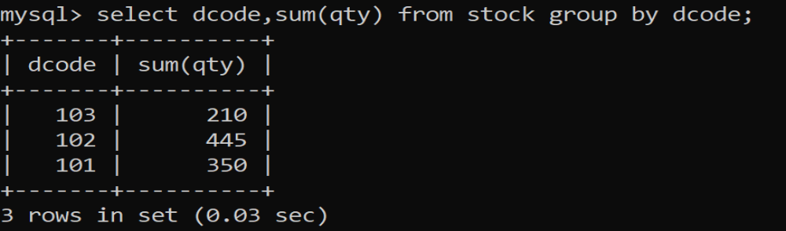

Part 5 Python Database connectivity
- Write a MySQL connectivity program in Python to
- Create a database school
- Create a table students with the specifications - ROLLNO integer, STNAME character(10) in MySQL and perform the following operations:
  - Insert two records in it
  - Display the contents of the table
- Perform all the operations with reference to table ‘students’ through MySQL-Python connectivity.
Answers:
Using pymysql - Code:
import pymysql as ms
#Function to create Database as per users choice
def c_database():
try:
dn=input("Enter Database Name=")
c.execute("create database {}".format(dn))
c.execute("use {}".format(dn))
print("Database created successfully")
except Exception as a:
print("Database Error",a)
#Function to Drop Database as per users choice
def d_database():
try:
dn=input("Enter Database Name to be dropped=")
c.execute("drop database {}".format(dn))
print("Database deleted sucessfully")
except Exception as a:
print("Database Drop Error",a)
#Function to create Table
def c_table():
try:
c.execute('''create table students
(
rollno int(3),
stname varchar(20)
);
''')
print("Table created successfully")
except Exception as a:
print("Create Table Error",a)

#Function to Insert Data
def e_data():
try:
while True:
rno=int(input("Enter student rollno="))
name=input("Enter student name=")
c.execute("use {}".format('school'))
c.execute("insert into students values({},'{}');".format(rno,name))
db.commit()
choice=input("Do you want to add more record<y/n>=")
if choice in "Nn":
break
except Exception as a:
print("Insert Record Error",a)

#Function to Display Data
def d_data():
try:
c.execute("select * from students")
data=c.fetchall()
for i in data:
print(i)
except Exception as a:
print("Display Record Error",a)
db=ms.connect(host="localhost",user="root",password="root")
c=db.cursor()
while True:
print("MENU\n1. Create Database\n2. Drop Database \n3. Create Table\n4. Insert Record \n5. Display Entire Data\n6. Exit")
choice=int(input("Enter your choice<1-6>="))
if choice==1:
c_database()
elif choice==2:
d_database()
elif choice==3:
c_table()
elif choice==4:
e_data()
elif choice==5:
d_data()
elif choice==6:
break
else:
print("Wrong option selected")

Output:
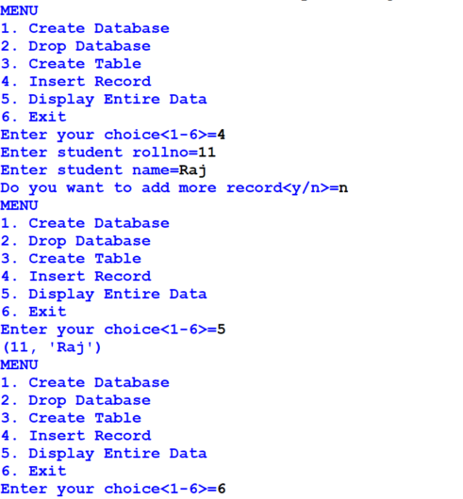
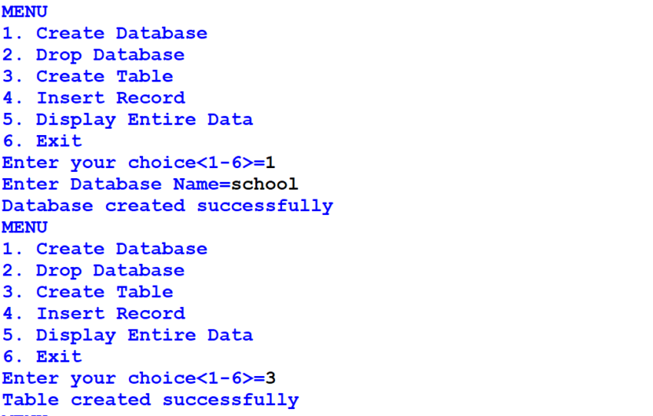

using mysqlconnector
import mysql.connector as ms
db=ms.connect(host="localhost",user="root",passwd="root",database='school')
cn=db.cursor()
def insert_rec():
try:
while True:
rn=int(input("Enter roll number:"))
sname=input("Enter name:")
marks=float(input("Enter marks:"))
gr=input("Enter grade:")
cn.execute("insert into students values({},'{}',{},'{}')".format(rn,sname,marks,gr))
db.commit()
ch=input("Want more records? Press (N/n) to stop entry:")
if ch in 'Nn':
break
except Exception as e:
print("Error", e)

def update_rec():
try:
rn=int(input("Enter rollno to update:"))
marks=float(input("Enter new marks:"))
gr=input("Enter Grade:")
cn.execute("update students set marks={},grade='{}' where rno={}".format(marks,gr,rn))
db.commit()
except Exception as e:
print("Error",e)

def delete_rec():
try:
rn=int(input("Enter rollno to delete:"))
cn.execute("delete from students where rno={}".format(rn))
db.commit()
except Exception as e:
print("Error",e)
def view_rec():
try:
cn.execute("select * from students")
import mysql.connector as ms
db=ms.connect(host="localhost",user="root",passwd="root",database='school')
cn=db.cursor()
def insert_rec():
try:
while True:
rn=int(input("Enter roll number:"))
sname=input("Enter name:")
marks=float(input("Enter marks:"))
gr=input("Enter grade:")
cn.execute("insert into students values({},'{}',{},'{}')".format(rn,sname,marks,gr))
db.commit()
ch=input("Want more records? Press (N/n) to stop entry:")
if ch in 'Nn':
break
except Exception as e:
print("Error", e)
def update_rec():
try:
rn=int(input("Enter rollno to update:"))
marks=float(input("Enter new marks:"))
gr=input("Enter Grade:")
cn.execute("update students set marks={},grade='{}' where rno={}".format(marks,gr,rn))
db.commit()
except Exception as e:
print("Error",e)
def delete_rec():
try:
rn=int(input("Enter rollno to delete:"))
cn.execute("delete from students where rno={}".format(rn))
db.commit()
except Exception as e:
print("Error",e)
def view_rec():
try:
cn.execute("select * from students")
data=c.fetchall()
for i in data:
print(i)
except Exception as e:
print("Error",e)
while True:
print("MENU\n1. Insert Record\n2. Update Record \n3. Delete Record\n4. Display Record \n5. Exit")
ch=int(input("Enter your choice<1-4>="))
if ch==1:
insert_rec()
elif ch==2:
update_rec()
elif ch==3:
delete_rec()
elif ch==4:
view_rec()
elif ch==5:
break
else:
print("Wrong option selected")
except Exception as e:
print("Error",e)
while True:
print("MENU\n1. Insert Record\n2. Update Record \n3. Delete Record\n4. Display Record \n5. Exit")
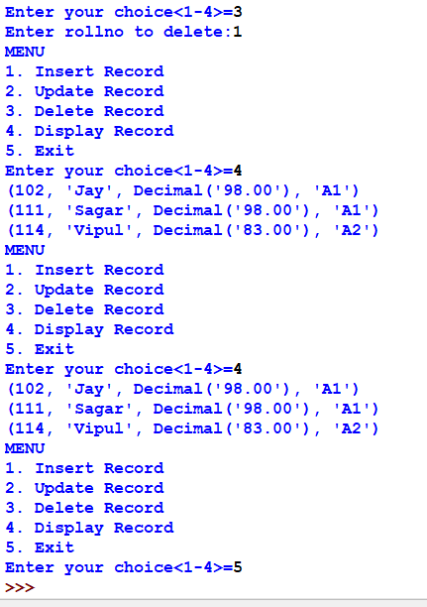
ch=int(input("Enter your choice<1-4>="))
if ch==1:
insert_rec()
elif ch==2:
update_rec()
elif ch==3:
delete_rec()
elif ch==4:
view_rec()
elif ch==5:
break
else:
print("Wrong option selected")
Output:
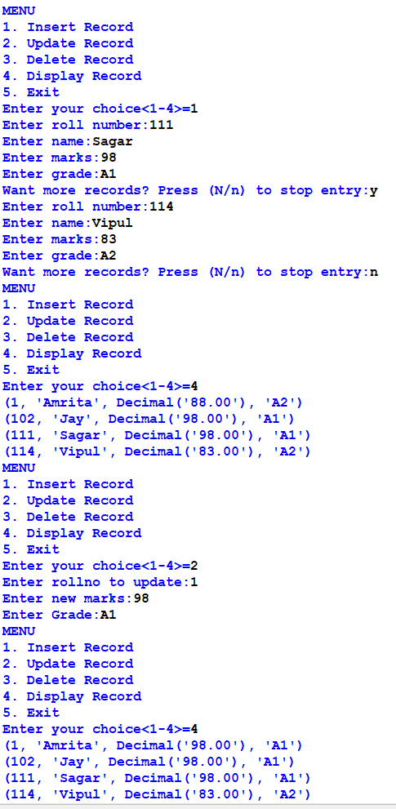
- Write a menu-driven program to store data into a MySQL database named shop and table customer as following:
- Add customer details
- Update customer details
- Delete customer details
- Display all customer details
import mysql.connector as ms
db=ms.connect(host="localhost",user="root",passwd="root",database='mydb')
cn=db.cursor()
def insert_rec():
try:
while True:
cid=int(input("Enter customer id:"))
cname=input("Enter name:")
city=input("Enter city:")
bill_amt=float(input("Enter bill amount:"))
cat=input("Enter category:")
cn.execute("insert into customer values({},'{}','{}',{},'{}')".format(cid,cname,city,bill_amt,cat))
db.commit()
ch=input("Want more records? Press (N/n) to stop entry:")
if ch in 'Nn':
break
except Exception as e:
print("Error", e)

def update_rec():
try:
cn.execute("select * from customer")
data=cn.fetchall()
for i in data:
ci=i[0]
cna=i[1]
ct=i[2]
b=i[3]
c=i[4]
cid=int(input("Enter customer id to update:"))
if cid==ci:
ch_cname=input("Want to update Name, Press 'Y':")
if ch_cname.lower()=='y':
cname=input("Enter new name:")
else:
cname=cna
ch_city=input("Want to update city, Press 'Y':")
if ch_city.lower()=='y':
city=input("Enter new city:")
else:
city=ct
ch=input("Want to update bill amount, Press 'Y':")
if ch.lower()=='y':
bill_amt=float(input("Enter new bill amount:"))
else:
bill_amt=b
ch_cat=input("Want to update Category, Press 'Y':")
if ch_cat.lower()=='y':
cat=input("Enter new category:")
else:
cat=c
cn.execute("update customer set cname='{}', city='{}', bill_amt={},category='{}' where cust_id={}".format(cname,city,bill_amt,cat,cid))
db.commit()
else:
print("Record Not Found...")
except Exception as e:
print("Error",e)
def delete_rec():
try:
cid=int(input("Enter customer id to delete:"))
cn.execute("delete from customer where cust_id={}".format(cid))
db.commit()
except Exception as e:
print("Error",e)
def view_rec():
try:
cn.execute("select * from customer")
data=cn.fetchall()
cnt=0
for i in data:
cnt=cnt+1
print("Record:",cnt)
print('~'*50)
print("Customer ID:",i[0])
print("Customer Name:",i[1])
print("City:",i[2])
print("Bill Amount:",i[3])
print("Category:",i[4])
print('~'*50)
except Exception as e:
print("Error",e)
while True:
print("MENU\n1. Insert Record\n2. Update Record \n3. Delete Record\n4. Display Record \n5. Exit")
ch=int(input("Enter your choice<1-4>="))
if ch==1:
insert_rec()
elif ch==2:
update_rec()
elif ch==3:
delete_rec()
elif ch==4:
view_rec()
elif ch==5:
break
else:
print("Wrong option selected")
Output:
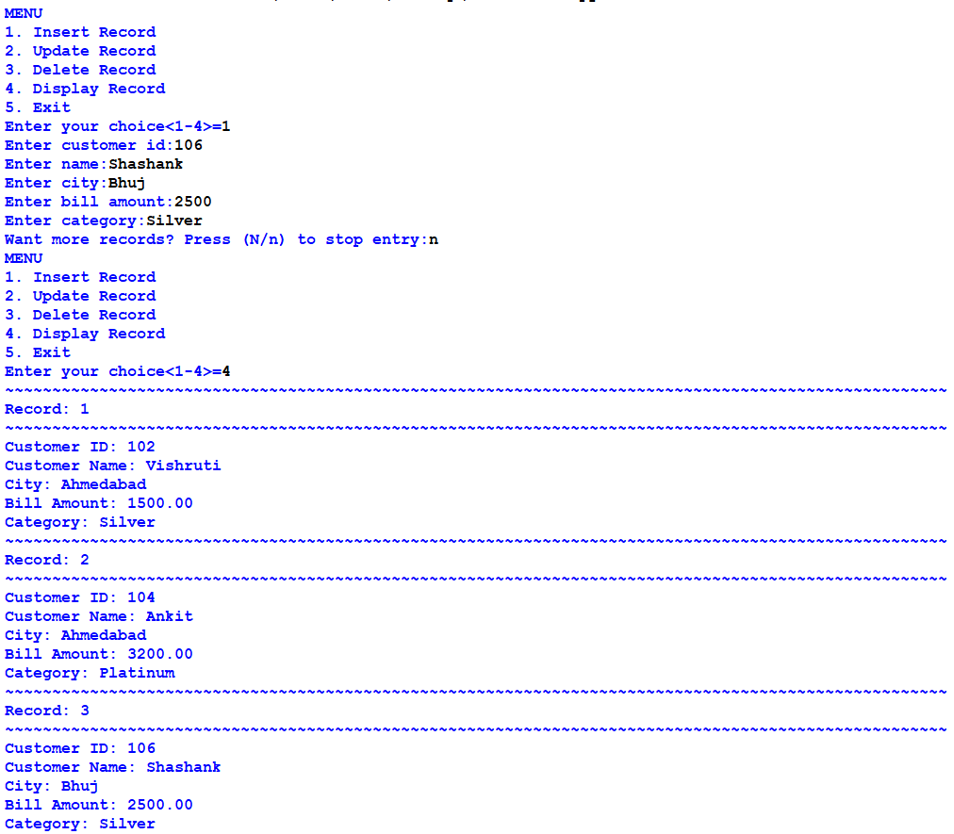
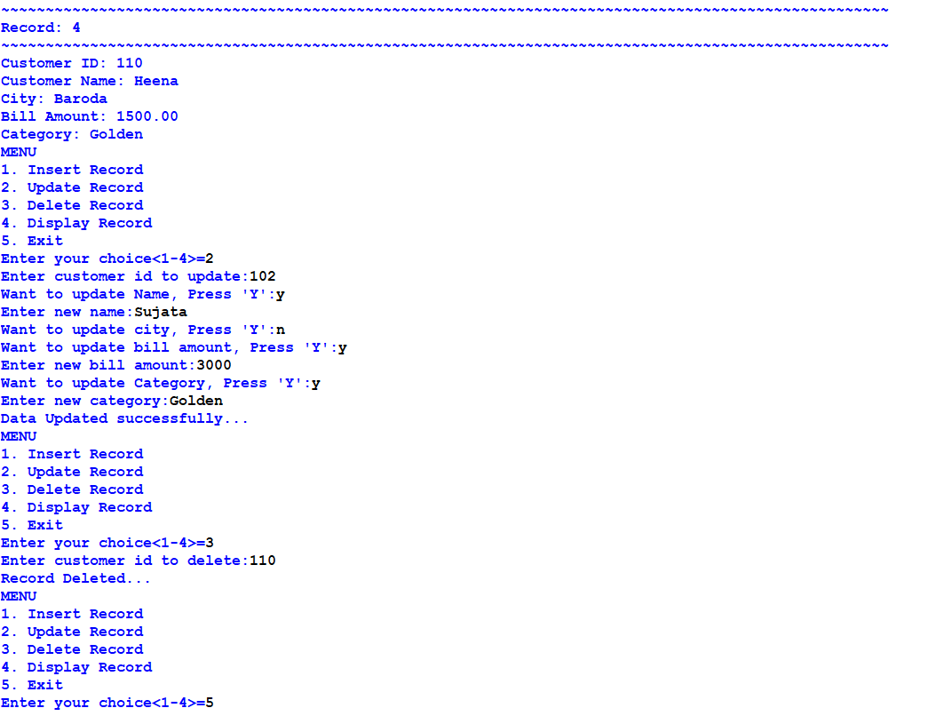
- Modify the above program and display the customer details based on the following menu:
- Display customer details by city
- Display customer details by bill amount
- Display customer details by name
- Display customer details by category
import mysql.connector as ms
db=ms.connect(host="localhost",user="root",passwd="root",database='mydb')
cn=db.cursor()

def byCity():
try:
city=input("Enter city to search:")
cn.execute("select * from customer where city='{}'".format(city))
data=cn.fetchall()
if data!=[]:
cnt=0
for i in data:
cnt=cnt+1
print('~'*100)
print("Record:",cnt)
print('~'*100)
print("Customer ID:",i[0])
print("Customer Name:",i[1])
print("City:",i[2])
print("Bill Amount:",i[3])
print("Category:",i[4])
else:
print("No records found for city ", city)
except Exception as e:
print("Error",e)

def byBillAmt():
try:
ba=input("Enter the bill amount:")
cn.execute("select * from customer where bill_amt={}".format(ba))
data=cn.fetchall()
if data!=[]:
cnt=0
for i in data:
cnt=cnt+1
print('~'*100)
print("Record:",cnt)
print('~'*100)
print("Customer ID:",i[0])
print("Customer Name:",i[1])
print("City:",i[2])
print("Bill Amount:",i[3])
print("Category:",i[4])
else:
print("No records found for bill amount ", ba)
except Exception as e:
print("Error",e)

def byName():
try:
name=input("Enter the name:")
cn.execute("select * from customer where cname='{}'".format(name))
data=cn.fetchall()
if data!=[]:
cnt=0
for i in data:
cnt=cnt+1
print('~'*100)
print("Record:",cnt)
print('~'*100)
print("Customer ID:",i[0])
print("Customer Name:",i[1])
print("City:",i[2])
print("Bill Amount:",i[3])
print("Category:",i[4])
else:
print("No records found for ", name)
except Exception as e:
print("Error",e)

def byCat():
try:
cat=input("Enter the cat:")
cn.execute("select * from customer where category='{}'".format(cat))
data=cn.fetchall()
if data!=[]:
cnt=0
for i in data:
cnt=cnt+1
print('~'*100)
print("Record:",cnt)
print('~'*100)
print("Customer ID:",i[0])
print("Customer Name:",i[1])
print("City:",i[2])
print("Bill Amount:",i[3])
print("Category:",i[4])
else:
print("No records found for category ", cat)
except Exception as e:
print("Error",e)

while True:
print('''
MENU
1.Display customer details by city
2.Display customer details by bill amount
3.Display customer details by name
4.Display customer details by category
5.Exit
''')
ch=int(input("Enter your choice<1-4>="))
if ch==1:
byCity()
elif ch==2:
byBillAmt()
elif ch==3:
byName()
elif ch==4:
byCat()
elif ch==5:
break
else:
print("Wrong option selected")
Output:
